Hands-on Exercise No. 3 – Solution
AI Using Python
DigiSkills 3.0 Batch-03

- Train-Test Split:
• Split the dataset into training and testing sets • Use an appropriate ratio (e.g., 80% training, 20% testing)
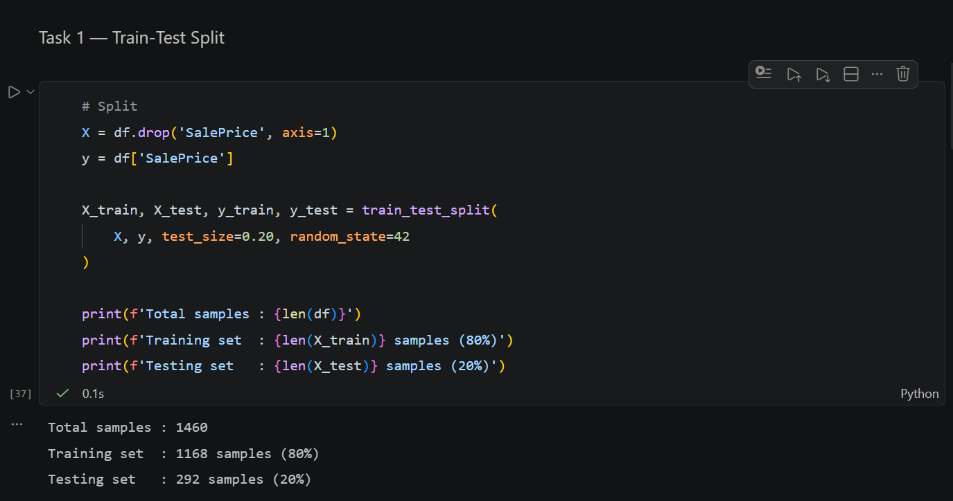

- Model Training:
• Train a Linear Regression model using the training data
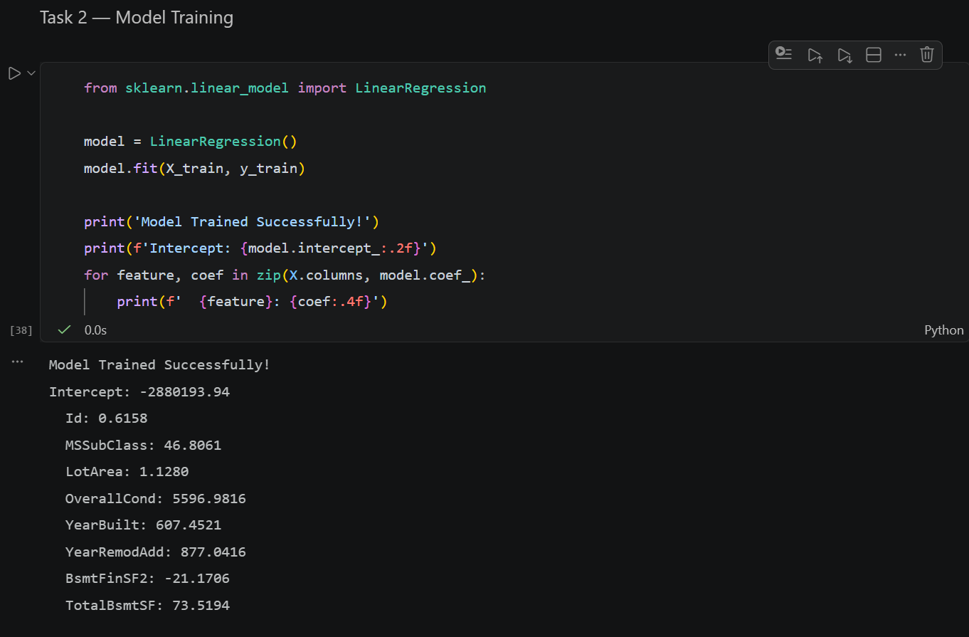
- Model Prediction:
• Use the trained model to predict house prices on the test data
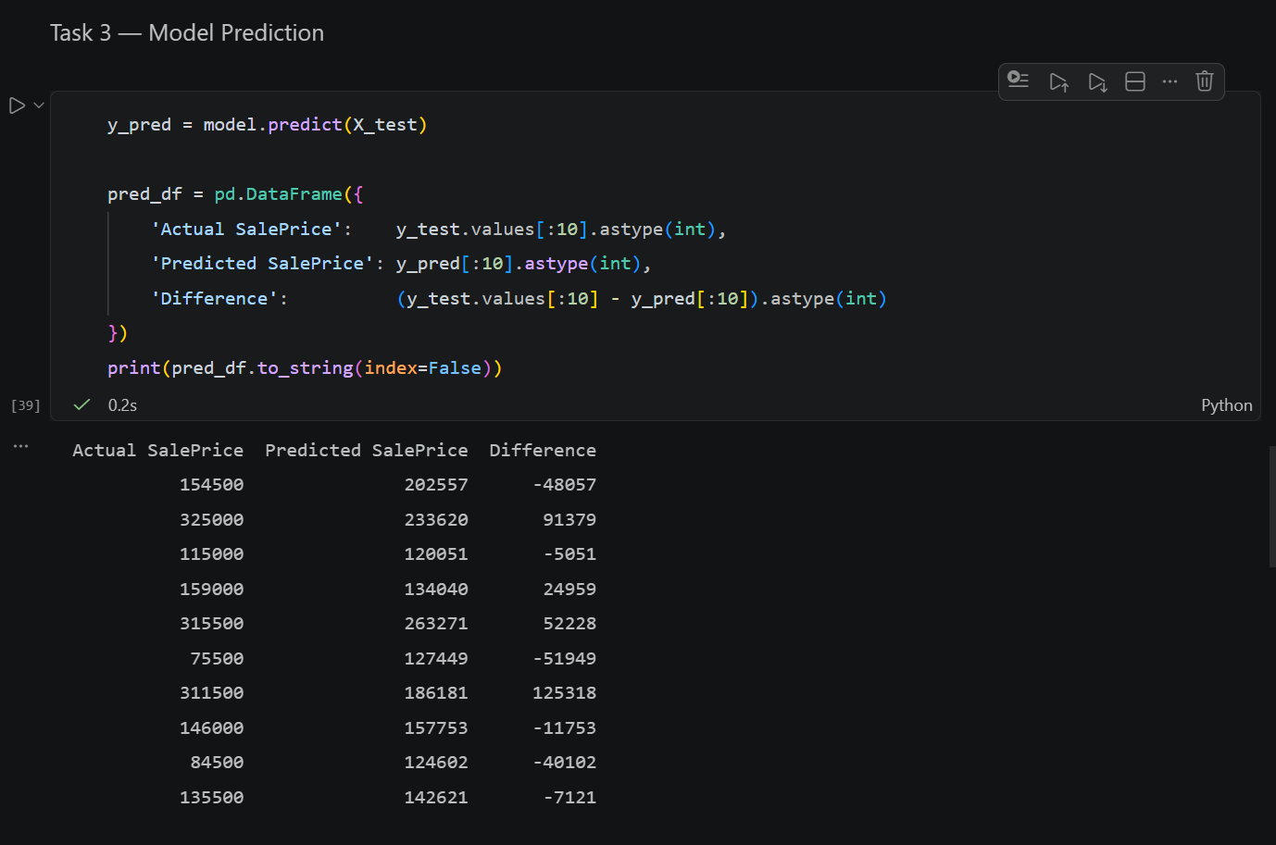

4. Model Evaluation; Evaluate the model using:
o Mean Absolute Error (MAE)
o Mean Squared Error (MSE)
o Root Mean Squared Error (RMSE) o R² Score
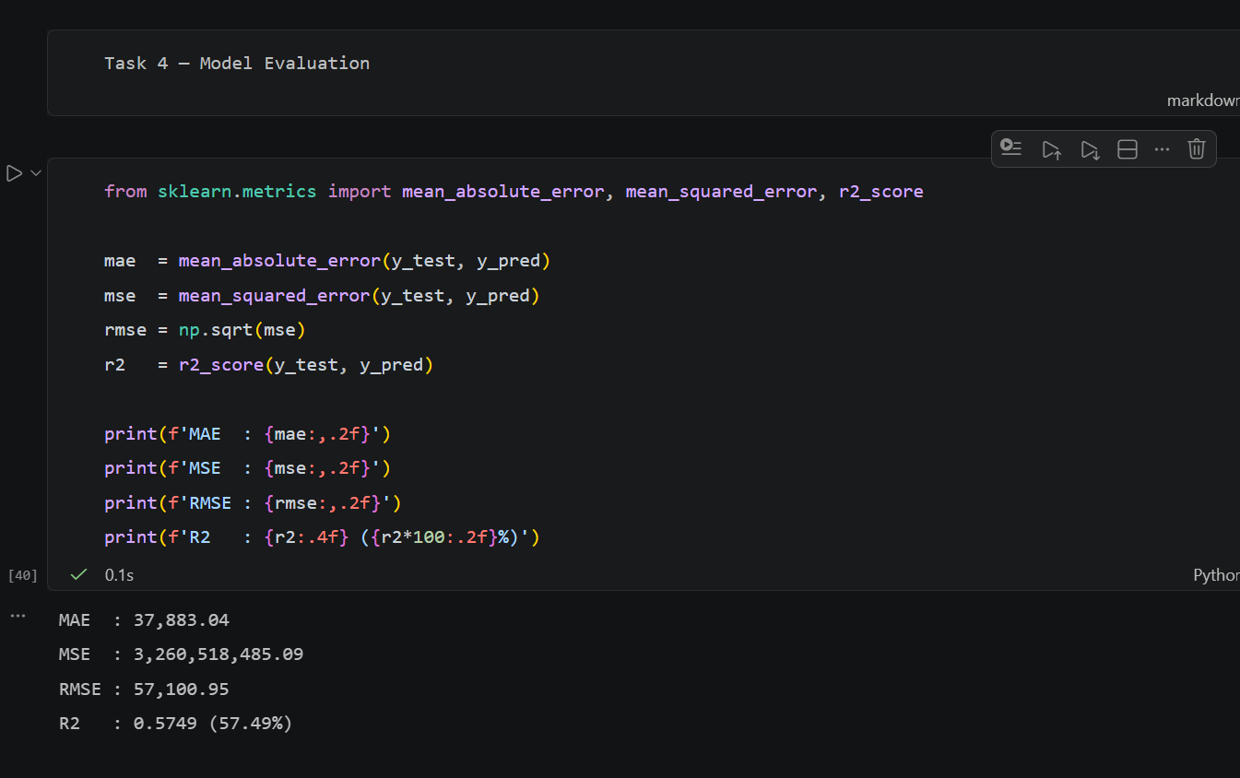

- Interpretation:
• Analyze the performance of the model • Discuss whether the model is accurate or needs improvement
